PSYCHOLOGICAL SCIENCE
_____________________________________________________________________________________
Research Report
DOES THE GUN PULL THE TRIGGER? Automatic Priming Effects of Weapon Pictures and Weapon Names
Craig A. Anderson, Arlin J. Benjamin, Jr., and Bruce D. Bartholow
University of Missouri—Columbia
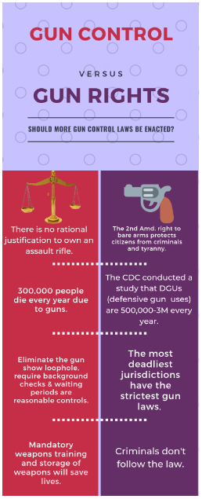
Abstract—
More than 30 years ago, Berkowitz and LePage (1967) published the ﬁrst study demonstrating that the mere presence of a weapon increases aggressive behavior. These results have been replicated in several contexts by several research teams. The standard explanation of this weapons effect on aggressive behavior involves priming; identiﬁcation of a weapon is believed to automatically increase the accessibility of aggression-related thoughts. Two experiments using a word pronunciation task tested this hypothesis. Both experiments consisted of multiple trials in which a prime stimulus (weapon or nonweapon) was followed by a target word (aggressive or nonaggressive) that was to be read as quickly as possible. The prime stimuli were words in Experiment 1 and pictures in Experiment 2. Both experiments showed that the mere identiﬁcation of a weapon primes aggression-related thoughts. A process model linking weapons as
primes to aggressive behavior is discussed brieﬂy.

In 1967, Berkowitz and LePage demonstrated that the presence of weapons (a riﬂe and a revolver) produced more retaliative aggression against an antagonist than did the presence of badminton rackets. These results, and several failures to replicate them (e.g., Page & Scheidt, 1971), led to considerable debate about the validity of the effect. But now, more than three decades later, it is clear that this “weapons effect” is real. It has been observed with knives as well as guns, with weapon pictures as well as real weapons, in ﬁeld settings as well as the psychological laboratory. Early concerns that the weapons effect might be an artifact of participants’ suspicion or experimenter demand have been met by studies revealing the opposite: The weapons effect occurs only when participants are not suspicious or under heavy experimenter demand (Carlson, Marcus-Newhall, & Miller, 1990; Turner, Simons, Berkowitz, & Frodi, 1977). It is clear that the presence of a weapon—or even a picture of a weapon—can make people behave more aggressively. In essence, the gun helps pull the trigger. How might this occur?

THE WEAPONS-AS-PRIMES HYPOTHESIS

The current explanation for this phenomenon involves the priming process (e.g., Berkowitz, 1990, 1993; Geen, 1990). “Weapon” concepts (e.g., gun, sword, club) are linked closely to aggression- and hostilityrelated concepts in semantic memory because of their similarity in meaning and their close association in common experience. For instance, most experiences with guns come from incidents in which a gun is used to threaten or harm someone, common experiences from watching television and movies, and from reading front-page news. Within some of the poorer regions in some large U.S. cities, people also receive too many ﬁrsthand experiences with guns and violence.
Figure 1 presents a simpliﬁed (and hypothetical) schematic of an associative memory structure in which the concept of “gun” is linked to a number of aggression-related concepts. It also shows (again in simpliﬁed form) two types of aggression-related concepts, several simple concepts and one more complex
script
(Abelson, 1981; Huesmann, in press). One assumption of this approach is that each concept in memory has an
activation threshold
. A concept may receive activation energy from various sources. When the total activation exceeds the threshold, the concept is activated and used. A second assumption is that concepts with similar meanings (e.g., hurt and harm) and those that frequently are activated simultaneously (e.g., shoot and gun), develop strong associations. These associations are illustrated by links between the concepts, with thicker lines representing stronger associations and shorter distances representing greater similarity of meaning. A third assumption is that when a concept is activated, its activation energy spreads to related concepts, as a function of how strongly they are associated. Scripts are sets of particularly well-rehearsed, highly associated concepts, often involving causal linkages, goals, and action plans (Abelson, 1981; Schank & Abelson, 1977). Because the items in a script are so highly associated, they may be thought of as a unitary concept in semantic memory as well. Figure 1 illustrates one such script, involving retaliation. Once associations with the concept “gun” have been formed, seeing a gun may increase the accessibility of the associated aggressive thoughts (including scripts) by a spreading-activation process (e.g., Collins & Loftus, 1975; Neely, 1977). Increased accessibility of hostile or aggressive thoughts may facilitate subsequent aggressive behavior in any of several ways, such as by biasing one’s interpretation of ongoing social interactions, or increasing the perceived appropriateness of an aggressive solution to a dispute. In the Figure 1 example, the sight of a gun activates the “gun” concept. Some activation spreads along associated pathways to other aggression-related concepts, including some that are in the retaliation script. If other aspects of the situation activate other parts of the script—for instance, if the person is struck in the back and experiences pain—the activation input gained from the mere presence of the gun may be sufﬁcient to trigger the retaliation script both as an interpretational guide to perception (e.g., whether a shove was intentional or accidental) and as a behavioral guide for action.

A MISSING LINK

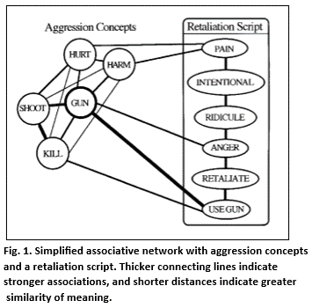
Considerable research in cognitive and social psychology has conﬁrmed the main aspects of these basic priming processes. As noted earlier, the weapons effect on aggressive behavior is well established. Similarly, merely memorizing aggressive words increases later aggressive behavior (Turner & Layton, 1976). Furthermore, decades of research on the effects of viewing television violence have yielded substantial links to subsequent aggressive behavior (e.g., Huesmann & Miller, 1994).
Numerous independent variables have been linked to increases in aggressive thoughts as well. For instance, Bushman and Geen (1990) found that participants who watched a violent movie clip wrote more aggressive thoughts than did those who watched a nonaggressive clip. More recently, two different laboratories have demonstrated that watching a violent movie clip can increase the accessibility of aggression related concepts as measured by semantic priming reaction time (RT) tasks (Anderson, 1997; Bushman, in press). Aggressive scripts have been identiﬁed by Huesmann and colleagues (e.g., Huesmann, in press), and have been linked to individual differences in aggressive personality (Dill, Anderson, Anderson, & Deuser, 1997). However, none of these studies links automatic priming processes with exposure to weapons. (Nor were these studies designed to do so.) Thus, the priming explanation of the weapons effect on aggressive behavior remains largely untested. What is necessary to test the weapons-as-primes hypothesis? In its most basic form, this hypothesis states that the mere cognitive identiﬁcation of a weapon increases the accessibility of aggression-related concepts in semantic memory. Movie clips, television shows, and verbal descriptions of violent behavior all are unsuitable independent variables for testing this particular hypothesis because they present more than a weapon identiﬁcation task as the prime stimulus; speciﬁcally, they also present actual aggressive behavior. The independent variable needs to be a simple semantic priming task, one in which weapon and nonweapon concepts are presented in an identiﬁcation task that is devoid of behavioral story, script, or action. Only one previous study comes close to this type of priming manipulation. Anderson, Anderson, and Deuser (1996) had participants rate 18 weapon or nature pictures on several rating dimensions roughly 10 min before aggressive cognitions were assessed. But even this manipulation involved more than merely identifying weapon or nonweapon primes. Figure 1 suggests two possibilities for the dependent variable. One can try to measure the presumed judgmental biasing effects of higher
level scripts, perhaps by presenting complex interpersonal scenarios and asking for aggression-related judgments. But biased judgments in complex interpersonal scenarios can arise from many sources, clouding interpretation. Alternatively, one can measure the accessibility of fairly basic concepts by using a standard RT task. Anderson et al. (1996) did this with a modiﬁed Stroop RT task, and found a signiﬁcant effect of the weapon versus nonweapon primes on RTs to aggression and nonaggression words. Though these results are supportive of the weapons-as-primes hypothesis, skeptics can argue that the rating aspect of the prime manipulation constituted more than identifying the stimulus. The present experiments contained both features deemed crucial for testing the weapons-as-primes hypothesis. Both used a standard facilitation RT paradigm to measure accessibility of aggressive cognition after mere identiﬁcation of weapon or nonweapon primes.

OVERVIEW AND RATIONALE

In two experiments, research participants viewed a series of weapon and nonweapon prime stimuli, each immediately followed by an aggression-related or aggression-unrelated word that they were to read out loud as quickly as possible. For each prime stimulus–target word pair, we recorded how long each participant took to begin pronouncing the target word after it appeared on a computer screen. RTs to this word pronunciation task are affected by the relation between the concept that has been most recently primed and the target word. RTs are relatively shorter when the prime stimulus and target word are from the same semantic category (e.g., Balota & Lorch, 1986; Carr, McCauley, Sperber, & Parmelee, 1982). If the priming explanation of the weapons effect is correct, then exposure to a weapon concept should increase the accessibility of aggression-related thoughts, thereby reducing the time needed to recognize and begin pronouncing aggression-related words. One key aspect of priming research concerns the
relative
nature of priming effects. One type of word may elicit faster responses than another regardless of the prime stimulus, making absolute RT changes of little interest. For example, showing that gun primes produce smaller RTs to aggressive words than to nonaggressive words would be of little value without knowing whether this difference was bigger or smaller than the corresponding mean RT difference between similar conditions with nonweapon primes. The priming hypothesis requires assessment of the effect of both weapon and nonweapon primes on RTs to both aggressive and nonaggressive words. In short, the test of this hypothesis requires assessment of all four cells of a 2 (prime: weapon vs. nonweapon)
×
2 (target word: aggressive vs. nonaggressive) factorial design. The priming hypothesis predicts that the relative accessibility of aggressive thoughts (average RT to nonaggressive target words minus average RT to aggressive target words) will be greater in the weapon-prime than in the nonweapon-prime condition.

EXPERIMENT 1
Method

Participants
Thirty-ﬁve undergraduates at the University of Missouri—Columbia voluntarily participated in this study. The 19 men and 16 women ranged in age from 18 to 24 years. Data from 3 participants were discarded Does the Gun Pull the Trigger?

because a high proportion of their trials had extremely long RTs as a result of their voices not being loud enough to trigger the voice key on their ﬁrst pronunciation attempts.

Materials, design, and apparatus
The design was a 2 (prime stimulus: weapon vs. nonweapon)
×

2 (target word: aggressive vs. nonaggressive) within-subjects factorial. Six weapon words (
shotgun, machete, ﬁst, bullet, dagger, grenade
) and six animal words (
rabbit, bug, dog, bird, butterﬂy, ﬁsh
) were used as prime stimuli. There were 24 aggressive (e.g.,
assault, injure
) and 72 nonaggressive (e.g.,
bloom, inept
) target words. For each participant, one weapon word and one animal word were paired with each target word in a randomly determined order. Thus, there were 192 trials. Table 1 lists the target words used in Experiments 1 and 2. Prime and target words were presented on an Apple Macintosh SE computer equipped with a MacRecorder microphone, which was used as a voice key. The word pronunciation program was created using HyperCard software.

Procedure
Each participant ﬁrst completed a consent form and several unrelated questionnaires. The experimenter explained the purpose of the study as a test of reading ability of various types of words. Additional instructions for the reading task were presented by the computer.
Each trial consisted of a prime word (on the screen for 1,250 ms), a blank screen (presented for 500 ms), and the target word. Participants were instructed to read each prime word silently, and then to read the target word aloud as soon as possible after it appeared. The computer automatically recorded the time between the onset of the target word and the MacRecorder’s recognition of an audible response. A 500-ms delay occurred between the vocalization of a target word and the onset of the next trial. Experimental sessions lasted about 30 min.

Results and Discussion

The weapons-as-primes hypothesis predicted a signiﬁcant interaction of prime stimulus and word type on RTs. Speciﬁcally, it predicted that the accessibility of aggressive words relative to nonaggressive words would be higher when the prime stimulus was a weapon word than when it was an animal word. Table 2 presents the raw means and standard deviations. To illustrate this weapons priming effect clearly, we calculated two
aggression accessibility
scores for each participant, one for the weapon-prime condition and one for the animal-prime condition. The means for these scores are displayed in Table 2. Aggression accessibility for each prime condition was calculated by subtracting the average RT to aggressive target words from the average RT to nonaggressive target words. Thus, higher scores indicate relatively greater accessibility of aggressive thoughts.
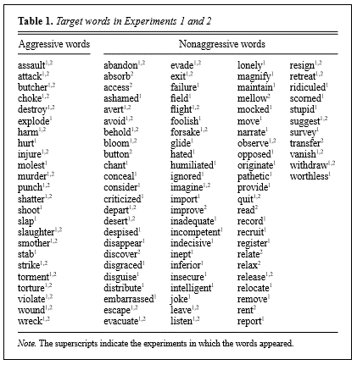
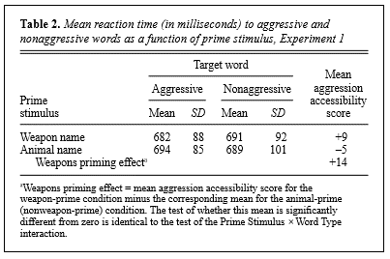

As predicted by the weapons-as-primes hypothesis, aggression accessibility scores were higher in the weapon-prime condition (
M
= 9 ms) than in the animal-prime condition (
M
= –5 ms). A repeated measures analysis of variance (ANOVA) revealed that this interaction was statistically signiﬁcant,
F
(1, 31) = 4.72,
p
< .04. In other words, on animal-prime trials, participants were slightly slower (5 ms) at naming aggressive words than nonaggressive words, but exposure to weapon primes reversed this pattern, enabling participants to name aggressive words 9 ms faster than nonaggressive words. The difference between these two means—the weapons priming effect (and the 2
×
2 interaction)—was +14 ms (
d
= .38). The ANOVA also revealed that neither the main effect of prime stimulus,
F
(1, 31) = 1.97,
p
> .15,
d
= .15, nor the main effect of word type,
F
(1, 31) = 0.21,
p
> .5,
d
= .05, approached signiﬁcance. Of course, as noted earlier, these main effects are totally irrelevant to the weapons-as-primes hypothesis. Experiment 1 provides clear support for the priming interpretation of the weapons effect. The priming procedures used in Experiment 1 differ considerably from the conditions used in studies of the weapons effect on aggressive behavior. One major difference is that we used printed words (e.g.,
shotgun
) to prime aggressive thoughts rather than real weapons or pictures of weapons. Thus, one might ask whether the weapons priming effect found in Experiment 1 would occur if pictures of weapons were used as the prime stimuli. Experiment 2 was designed to address this and several other questions.

EXPERIMENT 2

Experiment 2 replicated the word pronunciation task of Experiment 1 with several major changes. First, the prime stimuli were pictures rather than words. Second, the neutral (control) primes were plants rather than animals. The pictures were black-and-white drawings of weapons (guns, swords, and clubs) and plants (ﬂowers, fruits, and trees). Third, participants were instructed to identify aloud the category of each picture prime as it was presented. As in Experiment 1, participants were instructed to pronounce the target word as soon as it appeared.
Eighteen aggressive and 36 nonaggressive target words were used. Each of these 54 target words was paired once with each of the six different types of prime stimuli (e.g., with one gun, one sword, one tree picture), yielding a total of 324 trials. Because of the length of this task, the trials were presented in three equal blocks (108 trials each). Experiment 2 was thus a 2 (prime: weapon vs. nonweapon picture)
×
2 (target word: aggressive vs. nonaggressive)
×
3 (block) repeated measures design. The dependent measure was average RT on the pronunciation task.

Method

Participants
Ninety-three students (32 men and 61 women) enrolled in an introductory psychology course at the University of Missouri—Columbia participated in partial fulﬁllment of course requirements. Data from 1 participant were dropped because of the large number of extremely long RTs.

Materials and apparatus Participants were presented with 324 picture-word pairs. The pictures were 18 black-and-white line drawings, 9 weapons (3 guns, 3 clubs, and 3 swords) and 9 plants (3 fruits, 3 trees, and 3 ﬂowers). Small reproductions appear in Figure 2. Stimuli were presented on an Apple Macintosh SE computer using SuperLab software. A MacRecorder was used as a voice key to time the word pronunciation task. The three blocks of trials were separated by breaks of 20 s.
Procedure After obtaining informed consent, the experimenter explained the study as one involving accuracy and speed at reading. Participants were shown a cassette tape recorder that was used to record verbal responses, and were informed that performance was being recorded so that the researchers could check for errors. Each trial began with a 1,250-ms presentation of the picture prime. Participants were instructed to identify the picture category by naming
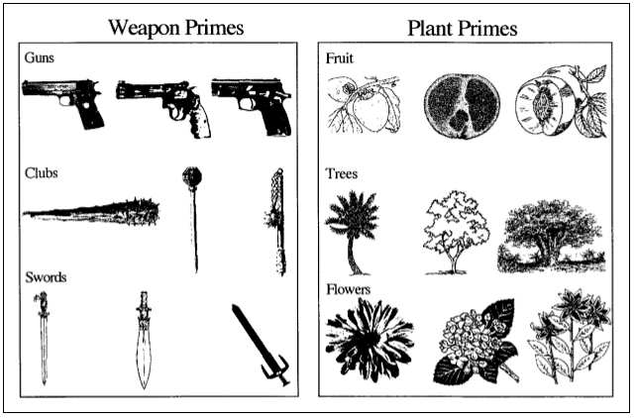

it (gun, club, sword, fruit, tree, ﬂower) out loud as quickly as possible. Next, a blank screen appeared for 500 ms, followed by the appearance of the target word. The target word remained on the screen until the participant pronounced the word in a sufﬁciently loud voice to trigger the voice key. A 500-ms delay followed, and then the next trial began. Sessions lasted from 45 to 60 min.
Results and Discussion
The weapons effect on aggressive cognitions was again assessed by computing two aggression accessibility scores for each participant, one for each prime condition. As predicted by the weapons-asprimes hypothesis, the repeated measures ANOVA revealed that aggressive cognitions were relatively more accessible after exposure to pictures of weapons (M = 11 ms) than after exposure to pictures of nonweapons (M = 5 ms), interaction F(1, 91) = 7.90, p < .01. As shown in Table 3, participants were 5 ms faster at naming aggressive words than nonaggressive words after exposure to plant pictures, but were 11 ms faster at naming the aggressive words after exposure to the weapon pictures. Thus, the overall weapons effect was 6 ms (d = .29). There was a nonsigniﬁcant main effect of prime stimulus, F(1, 91) = 2.56, p > .10, d = .17, but a signiﬁcant main effect of word type, F(1,
91) = 17.08, p < .01, d = .43. Participants were faster at naming the aggressive words (M = 577 ms) than the nonaggressive words (M = 585 ms). Note again that these main effects are irrelevant to the weaponsas-primes hypothesis. We ran additional analyses to see whether the size of the weapons effect was systematically related to trial block (ﬁrst block vs. second block vs. third block). We were particularly concerned about possible effects of fatigue that might reduce the weapons effect on later trials. Although the mean weapons effect did decrease across blocks (10, 6, and 1 ms), this block effect (actually, block-by-prime-by-target interaction) was not statistically reliable, F(2, 182) = 1.08, p > .30.
GENERAL DISCUSSION
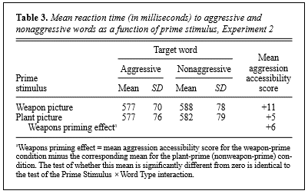
These two experiments demonstrate that simply identifying weapons increases the accessibility of aggressive thoughts. The absolute size of the weapons priming effect was somewhat larger in the word-prime (Experiment 1) than in the picture-prime (Experiment 2) version, but this difference was not signiﬁcant (p > .25). Furthermore, the two experiments differed in several other respects. The target words, type of neutral primes (animals vs. plants), and number of trials differed. An experiment speciﬁcally designed to test whether picture and word primes produce different-sized weapons effects might be interesting, but is not particularly relevant to our main theoretical thrust—that thinking about weapons increases accessibility of aggressive concepts in general. The methodological differences between our experiments broaden the generality of our ﬁndings. We have demonstrated that the weapons priming effect can be obtained with word or picture primes, with silent reading or out-loud naming of primes, and with animal or plant control primes. Our results are not restricted to a particular set of procedures and stimuli. Does the gun pull the trigger? Extant research suggests that it does. Our research demonstrates one way that exposure to weapons might increase aggressive behavior—by increasing the accessibility of aggressive thoughts. But how do primed aggressive thoughts increase actual aggressive behavior? We recently developed a general affective aggression model (GAAM) designed to incorporate major ﬁndings concerning affective aggression from a variety of sources (Anderson, Anderson, & Deuser, 1996; Anderson, Deuser, & DeNeve, 1995). This model is based primarily on Berkowitz’s (1990, 1993) cognitive neoassociation model, Geen’s (1990) affective aggression model, and Zillmann’s (1983) excitation transfer model. Our theoretical framework describes the processes through which a number of basic input variables may be transformed through a series of processes leading ultimately to aggressive behavior. Figure 3 displays a simpliﬁed version of GAAM speciﬁcally tailored to illustrate the weapons effect. Initially, the weapons effect increases the accessibility of aggression-related cognitions. These cognitions range in complexity from simple words (as in the present experiments) to more complex knowledge structures such as schemas and scripts (Huesmann, in press). Once this initial priming has taken place, a host of cognitive and affective processes may operate to increase aggressive behavior, but the present experiments do not speciﬁcally address these subsequent stages outlined by GAAM and other related models. For instance, aggressive cognitions may be directly linked to anger and increased arousal as well as to various appraisal processes. GAAM (and related models) predicts that weapon primes eventually increase the likelihood of the person behaving aggressively, at which point, dynamic social processes begin to operate. The target of such aggression is likely to respond in kind, producing an escalatory spiral of increasingly hostile cognitions, affect, and behavior. Although our studies provide an important link in the theoretical chain tying weapons exposure to aggressive behavior, additional work is necessary. A logical place to begin might be to examine the effects of weapon (vs. nonweapon) prime stimuli on hostile social interpretations and expectations (e.g., Dill et al., 1997). In the meantime, it is important to recognize that the mere presence of weapons can increase aggressive behavior by automatically priming aggressive thoughts.

