Team Contract

Project Name: Senior Capstone: Genealogical web-based information system for RootsTech

Code of Conduct: As a project team, we will:
- Create our own work and reference work that is not our own.
- Be open to compromise and recognize that team cohesion requires give-and-take.
- Complete assigned tasks by the deadline and communicate immediately as issues arise.
Participation: We will:
- Contribute fully to the best of our ability by taking the initiative to participate in tasks, especially where we have strengths. Meet se
- Those with greater abilities will help struggling members with guidance.
- Struggling team members will ask for clarification and/or assistance.
- Commit to Team Meetings on Mondays from 8:00-9:30 PM CST via Skype.
Communication: We will:
- Promote effective teamwork by allowing members to openly express ideas and feelings.
- Actively listen to team members and provide constructive and nonjudgmental feedback.
- Contribute to team cohesion by taking responsibility to communicate our own ideas in a respectful manner and consider cultural differences.
- To reduce repetition, communicate with the team via text or email immediately if taking the initiative on a task.
- Commit to checking email (uwm.edu) on a daily basis until the weekly deliverable has been submitted.
Problem Solving: We will:
- Use the strengths of the group and actively listen to each other to resolve problems.
- Allow members with interest and commitment to learn to contribute to resolving issues.

- We will not be afraid of making changes to how the team is organized or in its procedures.
Meeting Guidelines: We will:
- Make a concerted effort to be available for team meetings.
- Document the minutes with enough detail to fully bring team members, who could not attend the meeting, up to speed.
- Project Manager will lead the meetings and begin by listing the agenda of the meeting. Then, present the topics individually for discussion and allow team members to contribute their ideas.

Project Team Members Names and Sign-off:
Name | Sign-off on Team Contract
Kathleen Deboer
Jet Her | 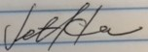
Kristen Kangas | 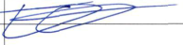
Jean-Marc Julien | 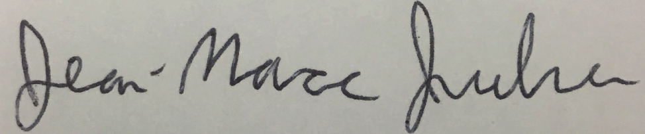
Jeremiah Rice | 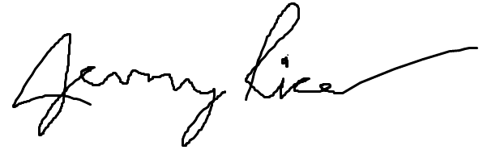

Resources

IT Solutions icon. Retrieved from https://www.itsolutions247.com/

Team contract. Retrieved from
https://www.georgebrown.ca/peerconnect/team-contract.pdf

