User Documentation
Group 1
04/22/2019
INFOST 490_201 Senior Capstone

Account Information:
URL for Prototype:
http://jeanmarcjulien.com/490/index.html

Table of Contents
Welcome 3
1.0 Registering an Account: 4
2.0 Login: 5
3.0 PLANT YOUR TREE: 7
4.0 LOG OUT PAGE: 10
5.0 TERMS AND CONDITIONS: 11
6.0 Privacy Policy: 13
7.0 Contact Us: 15
8.0 ABOUT US 16

Welcome

On behalf of the RootsTech team, we thank you for choosing RootsTech for your DNA and family ancestry needs.
This User Documentation tutorial is designed to provide users with step-by-step instructions on how to navigate the RootsTech website. This tutorial also provides users easy-to-follow images and instructions to view as they learn how to use our Family Tree Application.
After reading and reviewing this tutorial, users should be able to enact and execute all common tasks and functions found within the RootsTech Family Tree application. This includes basic activities such as: login, logout, plant a family tree, and uploaded documents.
If for any reason, should you find any technical or customer related issues during the use of this product, we encourage you to contact us at:

Customer Support
Phone: 1-408-891-6453
Email: customersupport@rootstech.com

Technical Support
Phone: 1-800-444-3333
Email: techsupport@rootstech.com

And as always, thank you for choosing RootsTech.

Sincerely,

The RootsTech Team

1.0 Registering an Account:

1.1) To register an account go to the RootsTech home page and select “Register”:
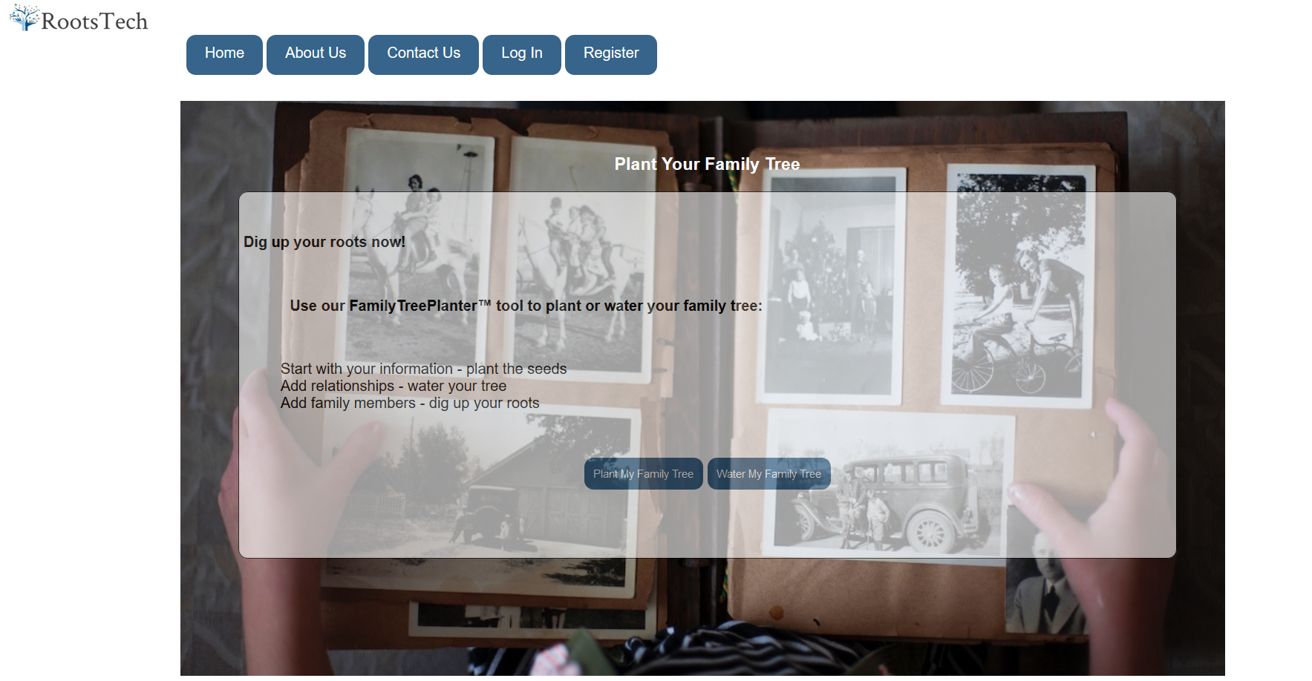
Figure 1.1 shows the RootsTech home screen with the Register button circled
1.2) Type in “Email” into the textbox
Click “Tab”
1.3) Create “Password” into the textbox
Click “Tab”
1.4) Confirm password into “Confirm Password” textbox
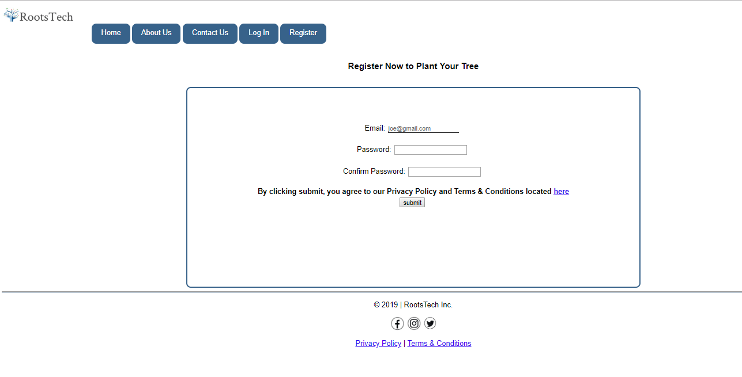
Figure 1.2 shows the Registration form
1.5) Review and Read “Privacy Policy” and “Terms of Service”, then click “Check Box”

1.6) When Registration form is complete, please review and click “Submit” to completed the register process.
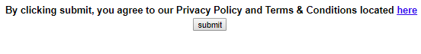
Figure 1.3 shows the “Submit” buttons on the Registration form

2.0 Login:

2.1) Once registered with the RootsTech system, click the “Login” tab:
Figure 2.1 shows the RootsTech home Screen with Log In button circled
2.2) Enter the personal email and personally selected login information
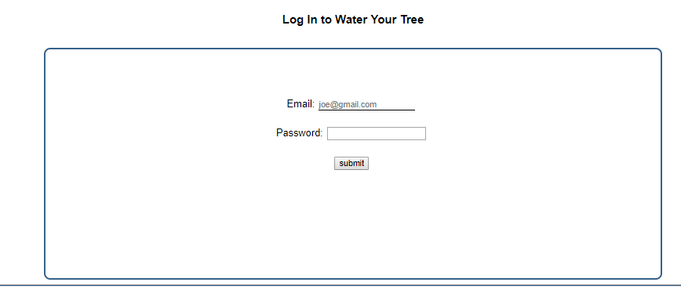
Figure 2.2 shows the RootsTech Login form
2.3) After Typing in Email Address and Password click “Submit” to access account.
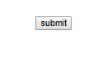

If you have successfully registered, follow these steps to 'Plant Your Tree':
- Complete the form in 'Step 1' below to add people to your table.
- Complete the Birth and Marriage information in 'Step 2' and 'Step 3' as desired, they are optional.
- Upon adding family members to your table in 'Step 1', you can connect family members by clicking on the parents in the dropdown menu.
- To view a person's tree, click on their picture.
See below for a visual example.

3.0 PLANT YOUR TREE:
3.1) Input personally selected “User” and “Family” members information into forms, as seen below:
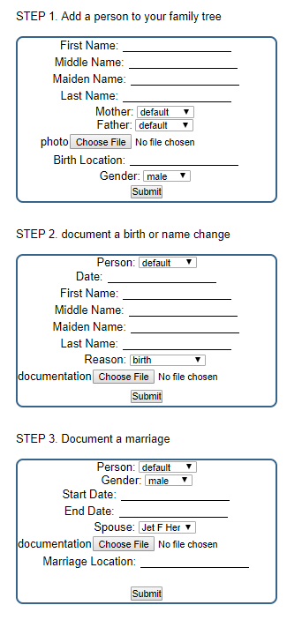
Click here to upload your “Marriage certificate”
Click here to upload your “Name change documents”
Click here to upload your “Photo”
***You may complete all 3 steps if you are married and have change your name. If you are single and have not change your name skip step 2 and 3.
Figure 3.1 is an example of how to plant your tree.
Please Note: On completing steps above (1 through 3), a table like the one below will populate as you add family members. It is important to select the correct mother and father in the mother and father column (i.e. Jet Her's parents are Kia and Yun in the table below).
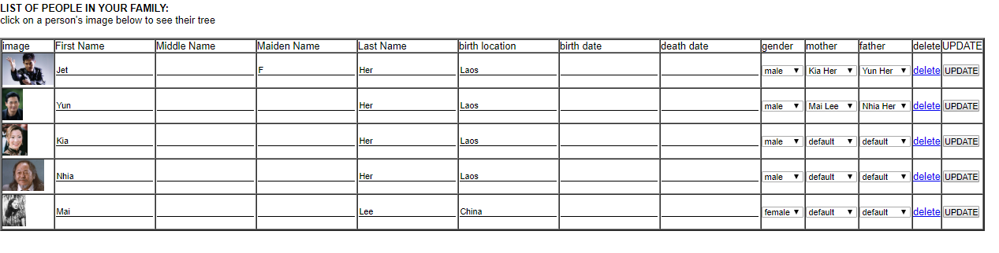
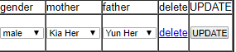
Figure 3.2 shows an example of the “Family Tree” table.
3.2) After you have added your family members to your table, click on your picture to see your family tree. Note, you will only see three generations at a time. However, you may build your tree as large as you want! To view another family member's tree, just click on their picture and they will populate at the top of the tree. For example, if you click on your mother, she will display at the top of the tree with her parents and grandparents below her. Below is an example of a family tree.
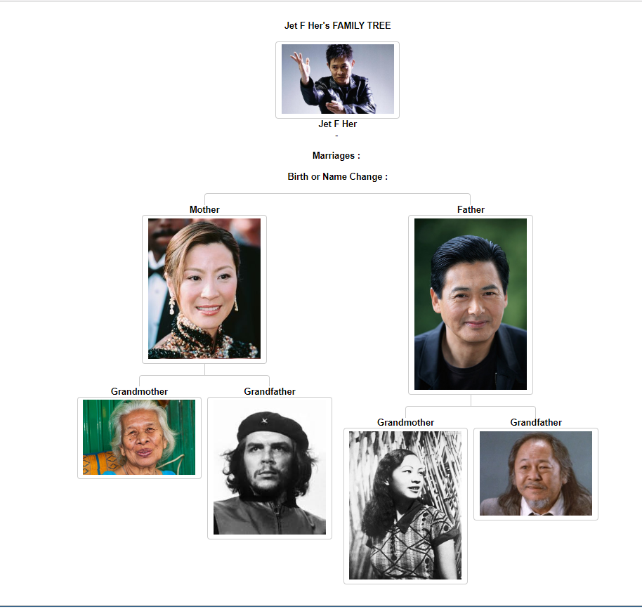
Figure 3.3 shows an example of a family tree
3.3) Default family tree diagram

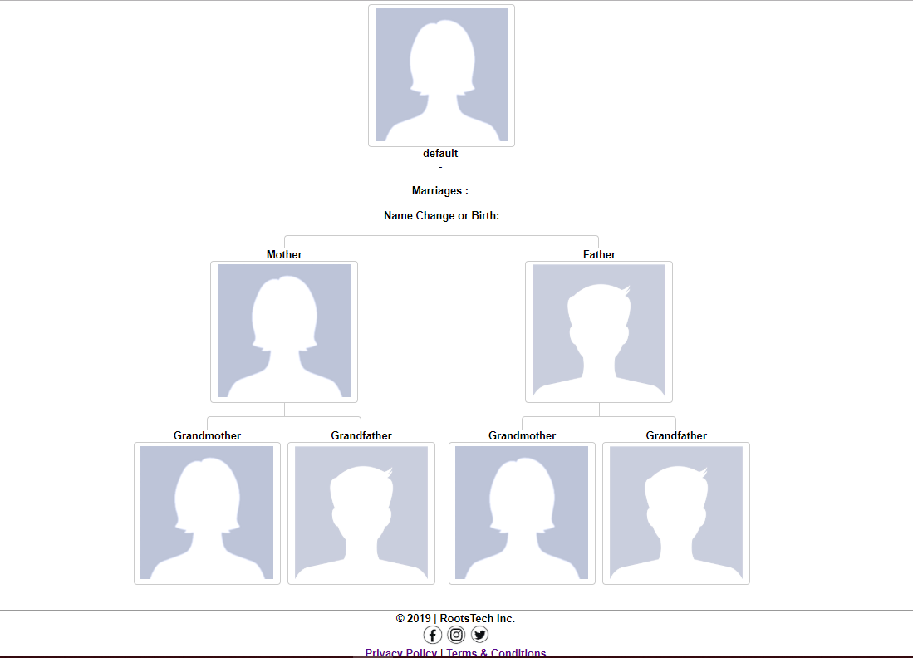
Figure 3.4: Default family tree.

4.0 LOG OUT PAGE:
4.1) To Log out scroll up to the top and select “Log Out” tab
“Click”
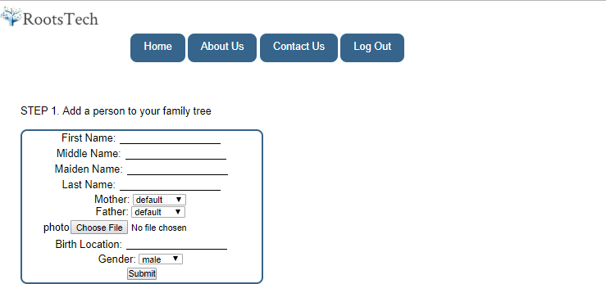
Figure 4.1 shows an example of Log out page.
4.2) Once the message stating, “You have been logged out!”
Then complete.
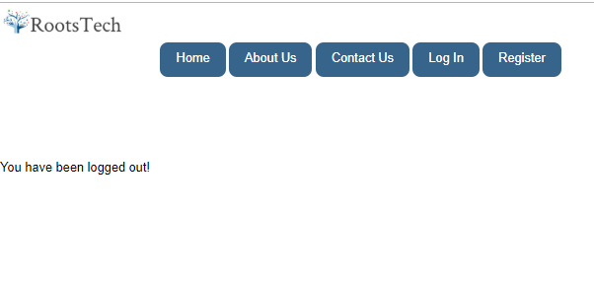
Figure 4.2 shows an example of Log out message.

5.0 TERMS AND CONDITIONS:
5.1) Go to the Home Screen and Scroll down to the bottom
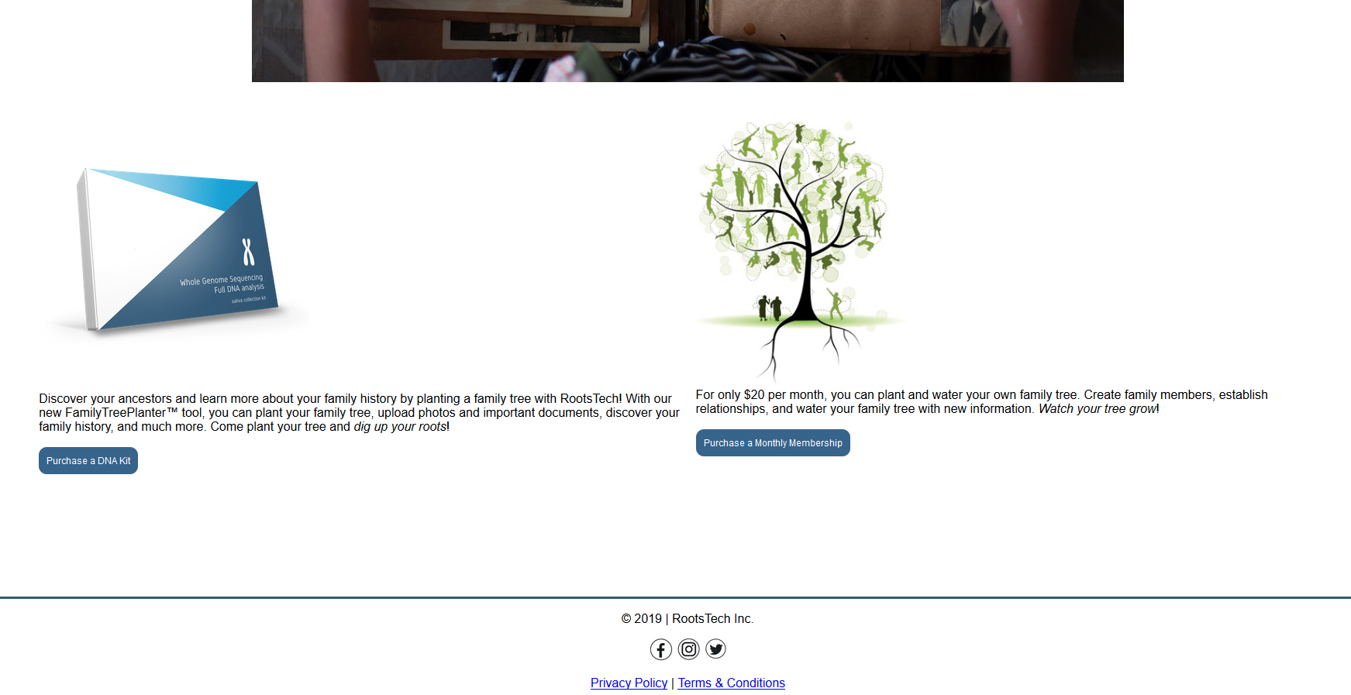

Figure 5.1 and 5.2 show the Privacy Policy and Terms & Conditions links.
5.2) For RootsTech Terms and Conditions
Click on “Terms & Conditions”

Figure5.3 shows direct location of Terms & Conditions link

5.3) Please read RootsTech’s Terms and Conditions
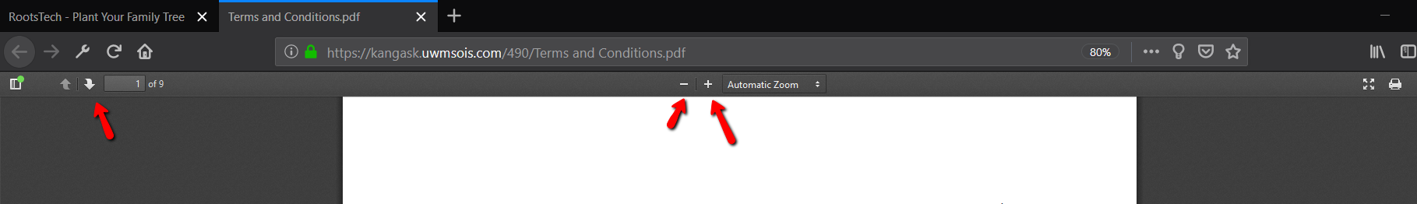
Figure 5.3 shows image of the Terms & Conditions page

5.4) Zoom in or out by clicking on “-” or “+”

Figure 5.4 shows the image sizing for readability

5.4) To turn the page click the “Up” arrow to move forward and “Down” arrow to move back
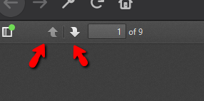
Figure 5.5 shows page turning tab

6.0 Privacy Policy:
6.1) Go to the Home Screen and Scroll down to the bottom
Figure 6.1 and 6.2 show the Privacy Policy and Terms & Conditions links.

6.2) For RootsTech Privacy Policy
Click on “Privacy Policy”

Figure 6.3 show the “Privacy Policy” link

6.3) Please read RootsTech’s Privacy Policy
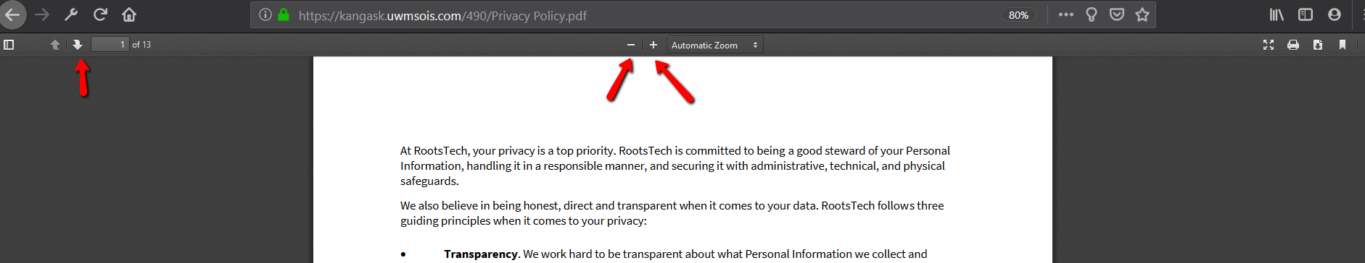
Figure 6.3 shows image of the Terms & Conditions page

6.4) Zoom in or out by clicking on “-” or “+”
Figure 6.4 shows the image sizing for readability

6.4) To turn the page click the “Up” arrow to move forward and “Down” arrow to move back
Figure 6.5 shows page turning tab

7.0 Contact Us:
7.1) On the Home Screen click on the “Contact Us” button
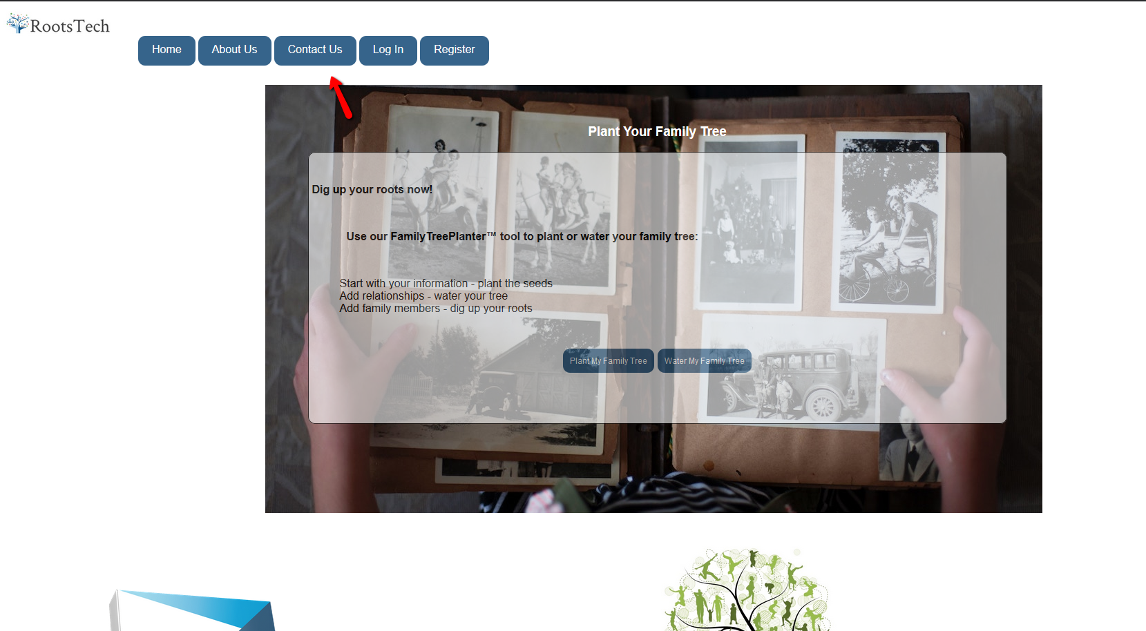
Figure7.1 shows an image of the Home page with an arrow locating the “Contact Us” tab
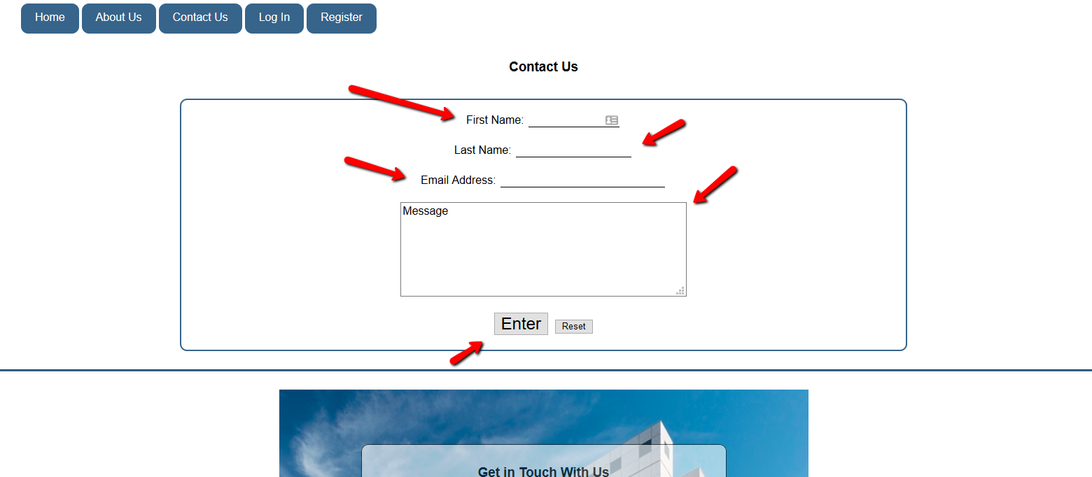
Figure 7.2 shows of the Contact us form with arrows indicating key information locations
7.2) Type in “First Name” into the textbox
Click “Tab”
7.3) Type in “Last Name” into the textbox
Click “Tab”
7.4) Type in “Email Address” into the textbox
7.5) Type in any questions or concern into textbox labeled “Messages”
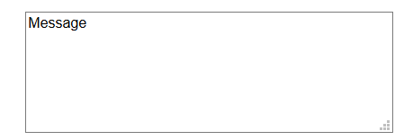
Figure 7.3 shows an image of the Message textbox
7.5) Please double check information placed and click the “Enter” button or to start over click “Reset”

Figure7.4 shows an image of the Enter and Reset buttons

8.0 ABOUT US
You may learn more about our RootsTech family at our 'About Us' page. Just click on the link shown below.
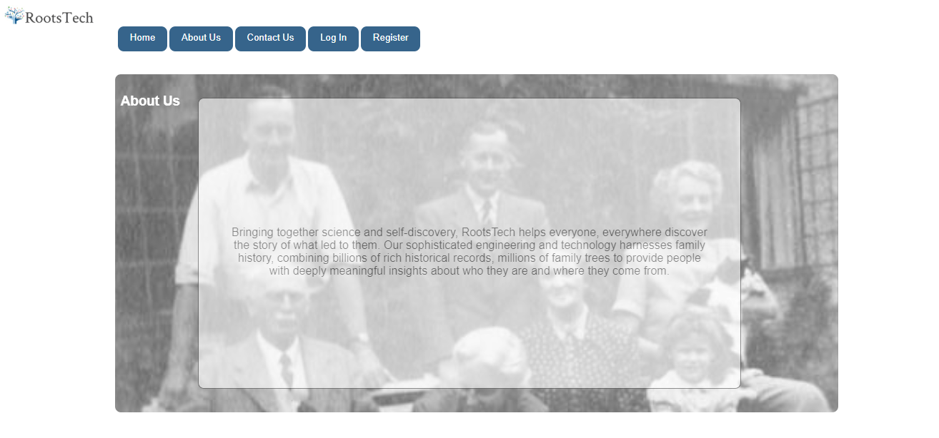
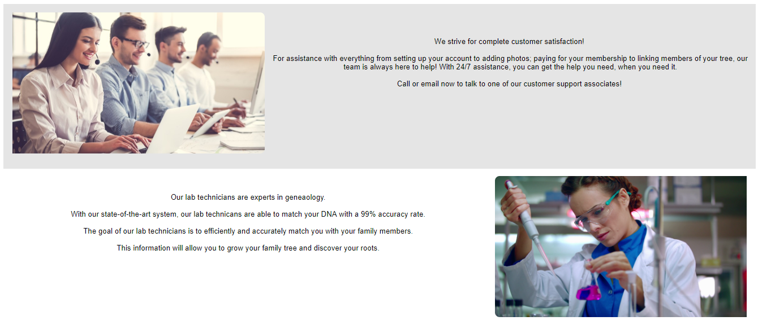
Figure 8.1 shows the About Us Page for RootsTech

Customer Support
Phone: 1-408-891-6453
Email: customersupport@rootstech.com

Technical Support
Phone: 1-800-444-3333
Email: techsupport@rootstech.com

